Final Project Report

NLP Chatbot Development using Dialogflow



Project Supervisor
Abdullah Qamar

Submitted By

F24PROJECT38A67

Saleha Shaukat BC230424569

NLP Chatbot Development using Dialogflow
Software Requirements Specification

Version 1.0



Group Id: F24PROJECT38A67
Supervisor Name: Abdullah Qamar

Revision History
Date (dd/mm/yyyy) | Version | Description | Author
30/11/2024 | 1.0 | This project is focused on developing a chatbot powered by AI for restaurants and hotels using Google Dialogflow technology. The chatbot is designed to streamline operations such as booking tables and rooms, discussing menu items, taking orders, and addressing inquiries. This initiative aims to enhance customer satisfaction and optimize restaurant and hotel processes. Customers will have the convenience of reserving tables, booking rooms, browsing menu choices, placing orders, and receiving responses to their queries via a platform. Using Natural Language Processing (NLP) technology, the chatbot facilitates communication, reduces wait times, and assists in lightening the workload for restaurant and hotel employees. | BC230424569

Table of Contents

- Scope (of the project)
- Functional Requirements Non Functional requirements
- Use Case Diagram
- Usage Scenarios
- Adopted Methodology
- Work Plan (Use MS Project to create Schedule/Work Plan)

SRS Document

Scope of Project
The purpose of this project is to develop an AI-powered chatbot specifically for restaurant and hotel businesses using Google Dialogflow. The chatbot will act as a virtual assistant, providing functionalities such as making table reservations, navigating the menu, placing food orders, checking room availability, making hotel reservations, and answering common customer queries. This system is designed to enhance customer interaction, improve operational efficiency, and offer greater convenience for both dining and accommodation services.
The chatbot will handle key customer requests such as:
- Answering frequently asked questions (FAQs)
- Processing restaurant and hotel reservation requests
- Navigating the food menu
- Assisting with placing orders
- Providing status updates on existing bookings
- Allowing users to modify and delete their orders.
- Allowing user to cancel and modify their reservations.
By offering quick, conversational responses, it ensures that customers receive timely assistance, accurate information, and a seamless experience across services.

Functional and non Functional Requirements:

Functional Requirements:
- User Inquiry Handling
The chatbot should understand and respond to common user queries related to restaurant and hotel services.
- Table Reservation Management (Restaurant)
  - Users should be able to book a table via the chatbot.
  - Users must provide the reservation date, time, and number of people.
  - Users should be able to view, modify, or cancel their reservation.
- Menu Navigation
  - The chatbot should display the restaurant menu upon request.
  - It should include dish names and prices
- Food Order Processing
  - Users should be able to place food orders through conversation.
  - The chatbot should allow order confirmation, modification, and cancellation.
- FAQs Handling
  - The chatbot should provide answers to frequently asked questions such as location, hours of operation, services offered, and contact details.
- Room Availability and Hotel Reservation
  - The chatbot should provide room availability for requested check-in and check-out dates.
  - Users must be able to reserve a room by specifying room type, dates, and email.
  - Users should be able to modify or cancel a room reservation using a reservation ID.
  - The system should calculate the total cost based on room type and number of nights.
- User Authentication and Account Management
  - Users should be able to register, log in, log out, and update their profile using email and password.
- Order Status Tracking
  - The chatbot should allow users to check their order status using an order ID.
- Room Service Inquiry
  - Users should be able to ask about available room services (e.g., food delivery, cleaning, extra towels, etc.).
- Product Inquiry (Restaurant)
- The chatbot should respond to inquiries regarding the availability and pricing of specific products or services.

Non Functional Requirements:
- Performance
- Response Time: The chatbot should reply to users' questions or requests within 2 seconds so that users don’t have to wait long.
- Handling Multiple Users: The chatbot should be able to handle many users at once, especially during busy times, without slowing down.
- Reliability
- Availability: The chatbot should be available most of the time, meaning it should work most of the time with very little downtime.
- Error Handling: If something goes wrong, the chatbot should give helpful error messages and continue working without crashing.
- Scalability
- Ability to Grow: The chatbot should be easily scalable to handle more users as the restaurant becomes more popular without causing any problems, like slow response times.
- Usability
- Easy to Use: The chatbot should be simple and easy for customers to use, even if they aren’t familiar with technology.
- Security
- Data Protection: The chatbot should keep customer information, such as names and order details, safe and secure.
- Maintainability
- Easy to Update: The chatbot should be easy to update if new features are added or changes are needed, without causing problems for users.
- Modular Design: The chatbot should have a modular design, allowing easy updates or changes to specific components without affecting the entire system.
- Availability and Fault Tolerance
- Always Available: The chatbot should be always available 24/7, especially during restaurant hours. If something goes wrong, there should be backup systems to keep it running.
- Fault Recovery: If there’s a problem, the chatbot should be able to fix itself or keep working without interrupting the user.
- Compatibility
- Works on Different Devices: The chatbot should be compatible with multiple devices and platforms, ensuring users can access it on smartphones, tablets, and desktops.

Use Case Diagram(s):

Usage Scenarios:

Use Case Title | Answer User Inquiries
Use Case Id | UC-001
Description | The chatbot understands and responds to user queries related to restaurant services.
Action | 1. Customer types a query  2. Chatbot processes the query using NLP.  3. Chatbot provides a relevant response or information.
Alternate Path | If the query is unclear, chatbot requests for clarification.
Pre-Condition | The chatbot must be active and connected to the system, and capable of understanding queries.
Post-Condition | The Customer inquiry is resolved, or they are prompted to ask another question.
Author | Bc230424569
Exception | If Chatbot fails to understand the query and will ask the user to rephrase the question for better understanding.

Use Case Title | Making Reservation
Use Case Id | UC-002
Description | The chatbot allows users to book a table at the restaurant by providing details like date, time, number of people.
Action | 1. Customer enters details( date, time, number of people).  2. Chatbot checks availability and confirms the reservation.
Alternate Path | If the requested time is unavailable, chatbot suggests alternative slots.
Pre-Condition | The Customer must have access to internet so that chatbot must have access to the reservation system .
Post-Condition | The customer receives a confirmation of the reservation with details.
Author | BC230424569
Exception | If the user enters invalid data, the chatbot will prompt for corrections.

Use Case Title | Navigate Menu
Use Case Id | UC-003
Description | The chatbot helps customers browse the restaurant’s menu by showing categories and item details like description and prices.
Action | 1. Customer asks to see the menu.  2. Chatbot displays categories of the menu.  3. Customer selects a category.  4. Chatbot shows items in the selected category along with descriptions and prices.  5. Customer asks for details of a specific item, if needed.
Alternate Path | If the customer directly searches for an item, the chatbot skips categories and shows the relevant item.
Pre-Condition | The chatbot must have access to the restaurant’s menu database.
Post-Condition | The customer successfully navigates the menu and views the required information.
Author | BC230424569
Exception | If the customer enters an invalid category, the chatbot prompts them to choose from the available categories.

Use Case Title | Process Order
Use Case Id | UC-004
Description | The chatbot processes the customer’s food order by selecting dishes and confirming the details.
Action | 1. Customer selects items from menu  2. Chatbot confirms the selected items and processes the order.
Alternate Path | If items are unavailable, chatbot suggests alternatives.
Pre-Condition | Customer must have access to the menu, and the chatbot must be connected to the order processing system.
Post-Condition | The order is successfully placed and confirmed.
Author | BC230424569
Exception | 1. The order cannot be placed due to system failure or unavailable menu items.  2. The Customer cancels the order before confirmation.

Use Case Title | Answer FAQs
Use Case Id | UC-005
Description | The chatbot answers frequently asked questions about restaurant details like hours, location, and services.
Action | 1. Customer asks question about restaurant details.  2. Chatbot retrieves and provides the required information.
Alternate Path | If the question is not recognized, chatbot asks for more details.
Pre-Condition | The chatbot must be able to recognize and respond to frequently asked questions.
Post-Condition | The customer receives accurate answers to their questions.
Author | BC230424569
Exception | Chatbot fails to retrieve or provide the requested information.

Use Case Title | Hotel Room Reservation
Use Case Id | UC-006
Description | The chatbot allows users to reserve a hotel room by collecting required details such as room type, check-in/check-out dats, and number of guests.
Action | 1. Chatbot initiates a hotel room reservation.  2. Chatbot asks for room type, check-in and check-out dates.  Customer provides the required information.  Chatbot checks availability and confirms the reservation.
Alternate Path | If the selected room type is unavailable, the user can select another room type if it is available.
Pre-Condition | Customer must have access to the internet and chatbot must be connected to the hotel reservation system.
Post-Condition | The reservation is saved and a confirmation message is sent to the customer.
Author | BC230424569
Exception | If the user enters invalid dates or room type, the chatbot prompt for correction.

Use Case Title | Check Room Availability
Use Case Id | UC-007
Description | The chatbot allows users to check availability of rooms based on selected dates and room type.
Action | 1. Customer selects Check Room Availability.  2. Chatbot asks for check-in and check-out dates and room type.  3. Customer provides required details.  4. Chatbot retrieves and displays available rooms.
Alternate Path | If no rooms are available, chatbot suggests other dates or room categories.
Pre-Condition | Customer must have access to live room availability data.
Post-Condition | Customer is shown available room options or informed of unavailability.
Author | BC230424569
Exception | If invalid dates are provided, chatbot prompts user to enter correct ones.

Use Case Title | Modify Room Reservation
Use Case Id | UC-008
Description | The chatbot allows customers to modify and existing room reservation using a reservation ID.
Action | 1. Customer selects Modify Room Reservation.  2. Chatbot asks for reservation ID and modification details.  3. Customer provides updates check-in/check-out dates or room type.  4. Chatbot updates the reservation and confirms changes.
Alternate Path | If the updated room is unavailable, chatbot offers alternatives.
Pre-Condition | The customer must have a valid reservation ID.
Post-Condition | The reservation is successfully updated.
Author | BC230424569
Exception | If th reservation ID is invalid, chatbot informs the customer and asks to retry.

Use Case Title | Cancel Room Reservation
Use Case Id | UC-009
Description | The chatbot enables customers to cancel a previously made room reservation.
Action | 1. Customer selects Cancel Room Reservation.  2. Chatbot requests the reservation ID for verification.  3. Customer enters the ID.  4. Chatbot cancels the reservation and confirms cancellation.
Alternate Path | If cancellation is not allowed for the given date, chatbot informs the user.
Pre-Condition | Reservation ID must exits and cancellation must be allowed per policy.
Post-Condition | The reservation is cancelled and a confirmation is provided.
Author | BC230424569
Exception | If the reservation is already cancelled or ID is invalid, chatbot notifies the customer.

Use Case Title | Modify Order
Use Case Id | UC-010
Description | The chatbot allows customers to modify food orders before they are confirmed.
Action | 1. Customer selects Modify Order.  2. Chatbot displays current order items.  3. Customer updates item quantity or adds/remoces dishes.  4. Chatbot updates the order and reconfirms the changes.
Alternate Path | If updates item is unavailable, chatbot suggest alternatives.
Pre-Condition | Customer must have an active order that has not been finalized.
Post-Condition | The order is modified and saved.
Author | BC230424569
Exception | If order id does not exit chatbot have to motify the user.

Use Case Title | Cancel Order
Use Case Id | UC-011
Description | The chatbot allows customers to cancel a food orders before confirmation.
Action | 1. Customer selects Cancel Order.  2. Chatbot confirms the request and asks for order ID if needed.  3. Customer confirms cancellation.  4. Chatbot cancels the order and provides confirmation.
Alternate Path | If cancellation is not allowed, chatbot notifies the user.
Pre-Condition | Order must exits and not be finalized.
Post-Condition | The order is cancelled and removed from the system.
Author | BC230424569
Exception | If order id does not exit chatbot have to motify the user.

Adopted Methodology

For my project, I have chosen a combination of the Waterfall model and the Incremental model. This hybrid methodology ensures a structured and sequential progression while allowing flexibility in development phases. Every phase is critically reviewed, and successful completion is required to advance to the next phase.

Waterfall model:
The Waterfall Model, the first process model introduced, is a linear-sequential life cycle model that is simple to understand and implement. In this model, each phase must be completed before proceeding to the next, ensuring no overlap between phases.

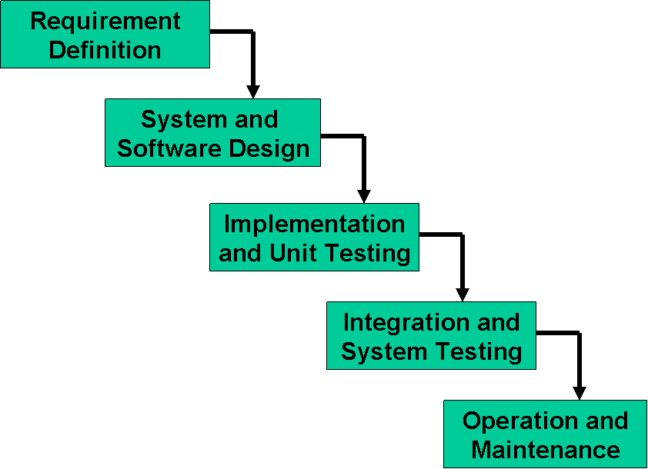
Incremental Model:

The Incremental Model is a software development process where requirements are divided into multiple standalone modules, each undergoing the phases of requirements, design, implementation, and testing. With each iteration, new functionality is added to the previous release, and the process continues until the complete system is developed.

Implementation, integration
Deliver to client
Design
Specification
Implementation, integration
Deliver to client
Design
Specification
Implementation, integration
Deliver to client
Design
Specification
Build 1
Implementation, integration
Deliver to client
Design
Specification
Build 2
Build 3
Build n
Specification team
Design team
Implementation, integration team

Phase-Wise Explanation of the Methodology

Phase 1: SRS (Software Requirements Specification)

- Waterfall Approach: In this initial phase, the scope, functional and non-functional requirements, use case diagrams, and usage scenarios are documented in detail. The SRS document must be reviewed and approved by the supervisor to proceed further.
- Reason: A clear and structured SRS provides a solid foundation and minimizes ambiguities in the later stages.

Phase 2: Design Document

- Waterfall Approach: This phase involves creating detailed designs, including ER diagrams, class diagrams, architecture design, and interface diagrams. The complete design document is reviewed and approved by the supervisor before moving forward.
- Reason: Finalizing the design ensures that the prototype development has a well-defined structure to follow.

Phase 3: Prototype Development
- Incremental Approach: In this phase, the system is developed incrementally as a working prototype. Each increment represents a functional part of the system. The prototype must be reviewed and approved as a complete phase before proceeding to the final deliverable.
- Reason: Using the Incremental model here allows testing and refining functionalities in smaller parts, ensuring a better-aligned and functional final deliverable.
Phase 4: Final Deliverable
- Incremental Approach: The final system is developed and refined in increments based on feedback from the prototype phase. This phase incorporates any necessary adjustments or enhancements identified earlier. Passing this phase is crucial to ensure the system meets all requirements and expectations.
- Reason: Incremental refinement ensures that the system is robust, user-friendly, and meets the project's goals effectively.
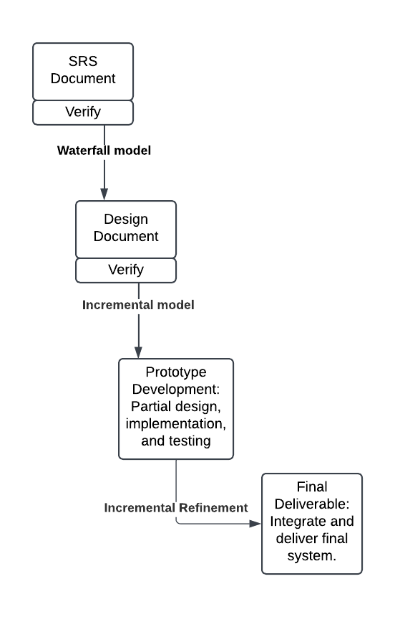Waterfall+Incremental model
The combination of Waterfall + Incremental model is an ideal methodology for my project. It ensures a structured, sequential progression in the initial phases (SRS and Design) while allowing iterative development and improvement in the later phases (Prototype and Final Deliverable). Mandatory phase approvals guarantee quality at every step, making this hybrid approach both practical and efficient.

Work Plan (Use MS Project to create Schedule/Work Plan)

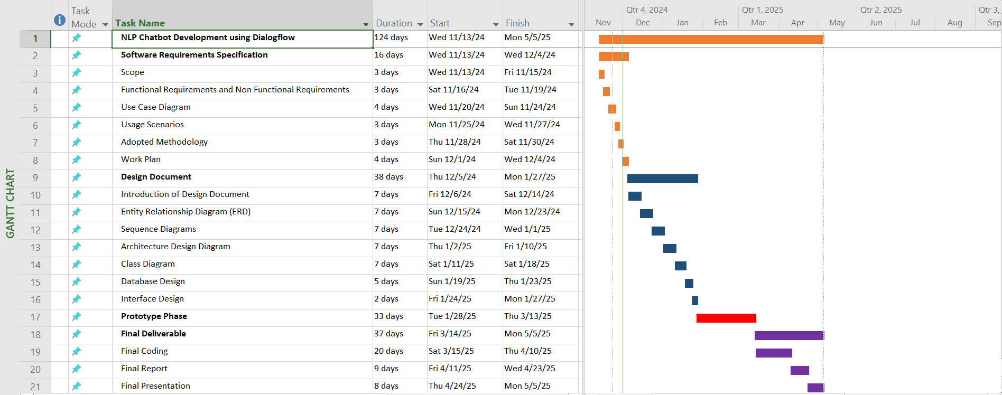

NLP Chatbot Development using Dialogflow
Design Document

Version 1.0

Revision History
Date (dd/mm/yyyy) | Version | Description | Author
26/02/2025 | 1.0 | This project is focused on developing a chatbot powered by AI for restaurants and hotels using Google Dialogflow technology. The chatbot is designed to streamline operations such as booking tables and rooms, discussing menu items, taking orders, and addressing inquiries. This initiative aims to enhance customer satisfaction and optimize restaurant and hotel processes. Customers will have the convenience of reserving tables, booking rooms, browsing menu choices, placing orders, and receiving responses to their queries via a platform. Using Natural Language Processing (NLP) technology, the chatbot facilitates communication, reduces wait times, and assists in lightening the workload for restaurant and hotel employees. | BC230424569

Table of Contents

- Introduction of Design Document
- Entity Relationship Diagram (ERD)
- Sequence Diagrams
- Architecture Design Diagram
- Class Diagram
- Database Design
- Interface Design
- Test Cases

Introduction of Design Document
- This design document serves as a structural guide to help developers build the restaurant chatbot.
- It provides a clear understanding of how the different components of the chatbot should interact with one another.
- The chatbot will be built using Google Dialog flow for training intents. For the backend, we will use Python (Flask); the frontend will be developed with HTML, CSS, and JavaScript; and MySQL will be used for managing the database.
- By using this design document, testers can use test cases to identify which parts of the system need more attention.
- This document helps avoid confusion during development. It ensures consistency across all major requirements such as order taking, checking order status, table reservations, browsing the menu, checking product availability, checking room availability, room reservations and handling common FAQs.
- The consistency of the design diagrams also helps development teams stay organized and build the system smoothly and accurately.

Entity Relationship Diagram (ERD) (To be developed using Microsoft Visio or any other drawing software of your choice)
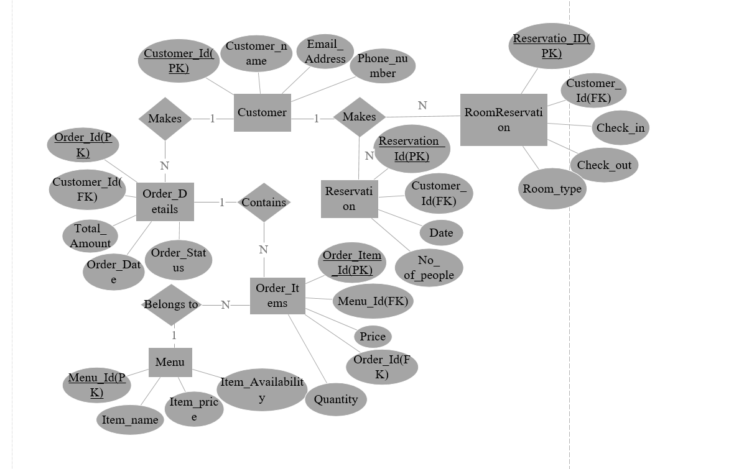
Sequence Diagrams (To be developed using Rational Rose or any other drawing software of your choice)

Architecture Design Diagram
Class Diagram

Database Design

Interface Design

First Screenshot:

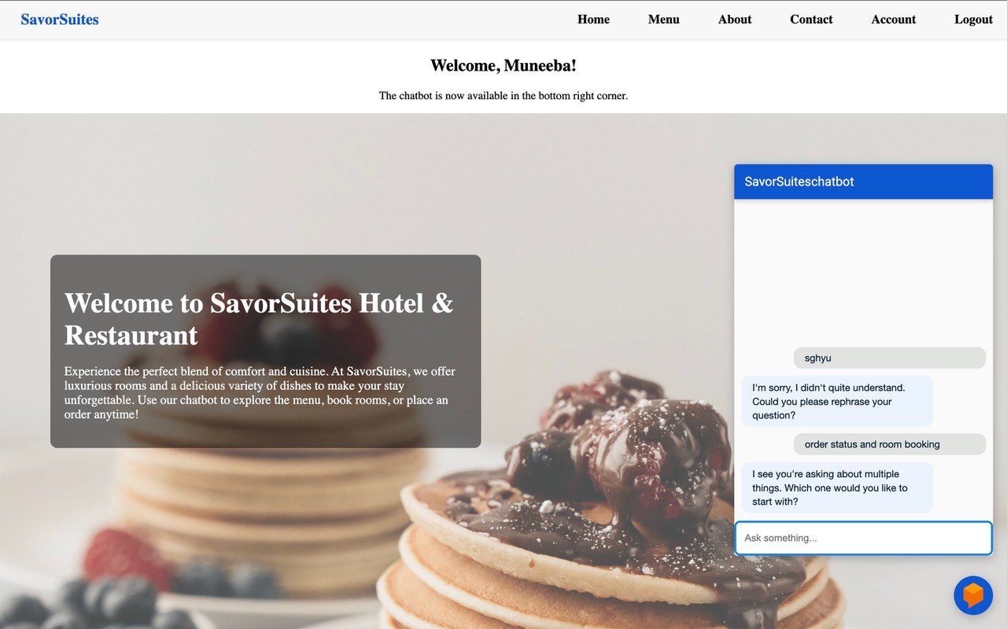

Second Screenshot:
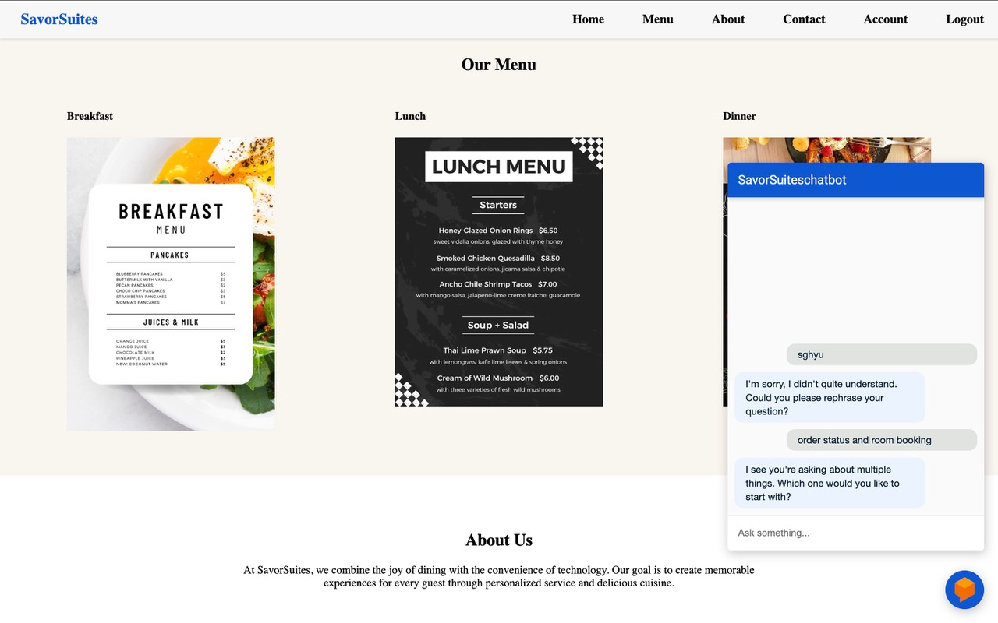

Third Screenshot:
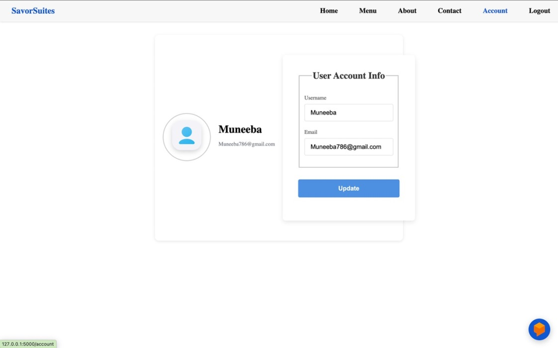

- Test Cases

Test Case #01: Verifying Chatbot's Response to User Inquiries

Preconditions: | - The user has initiated a conversation with the chatbot.  - The system is successfully connected to the backend.
Actions: | - The user submits a query such as: "What are the restaurant hours?"  - The chatbot processes the query.
Expected Results: | - The chatbot should provide an accurate and relevant response, for example: "Our restaurant operates from 10 AM to 10 PM every day."  - The system should generate the response without any errors.
Tested by: | BC230424569
Result: | Pass

Test Case #02: Verifying Reservation Functionality
Preconditions: | - The user is interacting with the chatbot interface.  - The user has access to the reservation system.
Actions: | - The user requests to make a reservation, for example: "I want to reserve a table for four at 7 PM tomorrow."  - The chatbot processes the reservation and provides confirmation.
Expected Results: | - The chatbot should confirm the reservation, e.g., "Your table for 4 at 7 PM tomorrow is successfully reserved."  - The system should save the reservation information.
Tested by: | BC230424569
Result: | Pass

Test Case #03: Verifying Display of Reservation Details
Preconditions: | - The user has already completed a reservation.  - The system has stored the reservation details correctly.
Actions: | - The user inquires about the details of their reservation, such as: "What time is my reservation?"  - The chatbot retrieves the relevant reservation information and displays it.
Expected Results: | - The chatbot should display the reservation details, e.g., "Your reservation for 4 people is confirmed at 7 PM tomorrow."
Tested by: | BC230424569
Result: | Pass

Test Case #04: Verifying Menu Navigation Feature
Preconditions: | - The user has accessed the chatbot interface.  - The system is equipped with an up-to-date menu.
Actions: | - The user asks to see the menu, for instance: "Can you show me the menu?"  - The chatbot displays the list of available items along with their prices.
Expected Results: | - The system correctly displays the menu with item names and prices as expected.
Tested by: | BC230424569
Result: | Pass

Test Case #05: Verifying Order Placement Feature
Preconditions: | - The user has accessed the menu.  - The user is logged into the chatbot interface.
Actions: | - The user selects an item from the menu (e.g., "I’d like to order a pizza").  - The chatbot processes and confirms the order.
Expected Results: | - The chatbot confirms the order, e.g., "Your pizza has been ordered successfully."  - The system updates the order details accordingly.
Tested by: | BC230424569
Result: | Pass

Test Case #06: Verifying Modify or Cancel Order Functionality
Preconditions: | - The user has already placed an order.  - The system supports modifications or cancellations of orders.
Actions: | - The user requests to modify or cancel the order, e.g., "Can I change my pizza order?"  - The chatbot confirms the change or cancellation.
Expected Results: | - The chatbot should allow modifications or cancellations and update the system accordingly.  - The chatbot confirms the change, e.g., "Your pizza order has been updated."
Tested by: | BC230424569
Result: | Pass

Test Case #07: Verifying FAQs Responses
Preconditions: | - The user has opened the chatbot interface.  - The system contains a set of predefined FAQs.
Actions: | - The user asks a frequently asked question, e.g., "What time do you close?"  - The chatbot provides the relevant FAQ answer.
Expected Results: | - The chatbot should provide the correct response to the FAQ, and the reply should be accurate and timely.
Tested by: | BC230424569
Result: | Pass

Test Case #08: Verifying Handling of Invalid Input
Preconditions: | - The user is interacting with the chatbot.  - The user enters an unclear or invalid query.
Actions: | - The user inputs an ambiguous or incorrect query, e.g., "bljahsldksld" or "Can I order food?" without providing enough context.  - The chatbot asks the user for clarification or rephrasing.
Expected Results: | - The chatbot should respond with a clarification request, e.g., "Sorry, I did not understand. Could you please rephrase?"
Tested by: | BC230424569
Result: | Pass

Test Case #09: Verifying Hotel Room Reservation
Preconditions: | - The user is interacting with the chatbot.  - User has internet access, logged in
Actions: | User provides check-in/check-out dates, room type.
Expected Results: | Chatbot confirms hotel room reservation and stores it.
Tested by: | BC230424569
Result: | Pass

Test Case #10: Verifying Check Room Availability
Preconditions: | Room database is connected and active.
Actions: | User asks for available rooms on certain dates.
Expected Results: | Chatbot shows available options or says none available.
Tested by: | BC230424569
Result: | Pass

Test Case #11: Verifying Modify Room Reservation
Preconditions: | User already has a reservation ID.
Actions: | User requests to change check-in date/room type.
Expected Results: | Chatbot updates the reservation and confirms changes
Tested by: | BC230424569
Result: | Pass

Test Case #12: Verifying Cancel Room Reservation
Preconditions: | A valid reservation exits.
Actions: | User provides reservation ID to cancel.
Expected Results: | Chatbot cancels and confirms.
Tested by: | BC230424569
Result: | Pass

Structure of the Intents

Intent Name | Purpose | Parameters | Uses Webhook | Example User input
Default Welcome Intent | Greets the user | None | Yes | Hey, hello
Default Fallback Intent | Handles unmatched inputs | None | No | sdfgh
Menu intent | For showing different menu options | None | Yes | Can I see your menu?
Invalid Input | Handles incomplete/ missing input cases | wrong-id | Yes | My order id is ab
Multiple Intents Detected | When more than one intent is matched | None | Yes | Order status and product availability
Order taking Intent | Takes food orders from the users | quantity, ProductName | Yes | I want to order food.
Order taking intent -add | Add more products on existing order | Order_id ,quantity,ProductName | Yes | And I want to add mango juices well.
Order taking intent -cancel | For cancel user order | None | Yes | I wanna cancel my order
Order Status Intent | For checking order status | Order_id | Yes | Can you check my order status?
Product related query | Checks if the specific item is available | ProductName | Yes | Is orange juice available?
Payment method | Providing the information of payment method. | None | No | What the payment method do you provide?
Restaurant Location | Tells restaurant address | location | No | What is location of your restaurant?
Restaurant timing | Tells opening and closing timing | Time, date | No | What is the timing of your restaurant?
Service offered | Confirms takeaway and dine-in availability. | Service_offered | No | What the services do you providing?
Table reservation intent | Books a table for the customer | date, number, time | Yes | I want to reserve a table?
Room Availability Intent | Check available rooms by date/type | check_in, check_out,room_type | Yes | Do you have any suite room available from 12 june to 14 june?
Room Reservation Intent | Book a hotel room | check_in_date, check_out_date,email,room_type | Yes | I want to book a single room from 5 august to 7 August
Cancel Room Reservation | Cancel a room reservation. | reservation_id | Yes | Cancel my booking with ID 12345.
Modify Room Reservation | Change dates or room type for an existing reservation. | Reservation_id,new_check_in_new_,  check_out_date,new_room_type | Yes | Change my booking to 25 june to 28 june for a suite room.
Thank you/Ending Intent | Respond to Thank you,bye | None | No | Thankyou, Goodbye
Room price Inquiry | Ask about room pricing. | Room_type | No | How much is a double room per night?

